NAME: SIVANJALI.S

REG.NO: 192210508

SERIAL NO: 30

COURSE NAME: FUNDAMENTALS OF

COMPUTING

COURSE CODE: CSA5779

SLOT NAME:D

PROGRAM:

1.NUMBER SERIES 1,2,3,4,5,6,7……..N

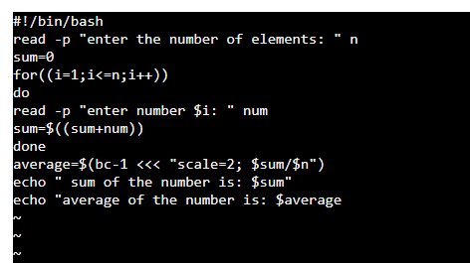

OUTPUT:

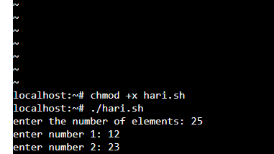

PROGRAM:

2.FINDING NUMBER WHEATHER EVEN OR ODD

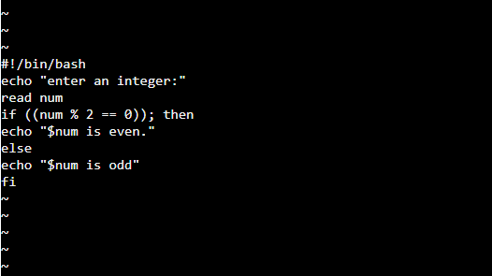

OUTPUT:

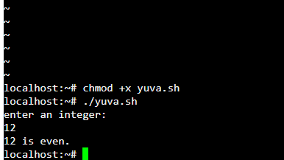

PROGRAM :

3.FINDING A NUMBER WHEATHER NEGATIVE OR POSITIVE

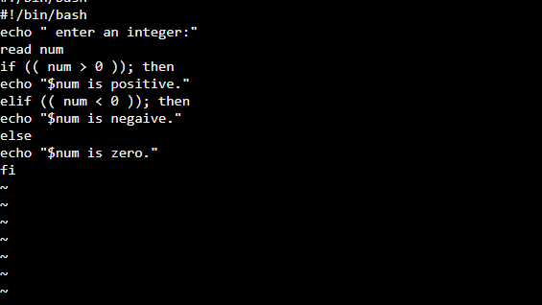

OUTPUT:

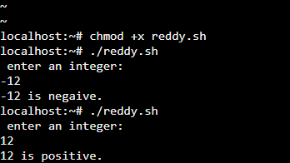

PROGRAM:

4.SUMMING UP THE ODD NUMBER SERIES :

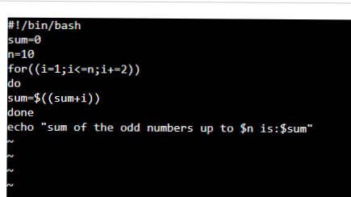

OUTPUT:

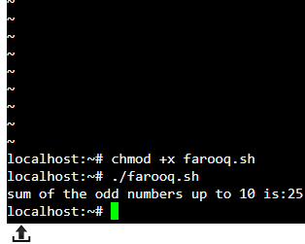

PROGRAM:

5.SWAPPING OF TWO NUMBERS

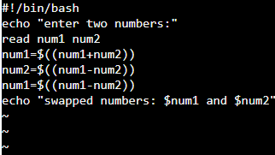

OUTPUT:

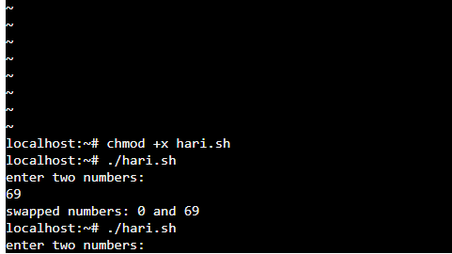

PROGRAM:

6. SUMMING UP EVEN NUMBER SEERIES

INPUT :

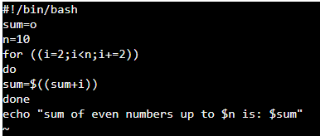

OUTPUT: 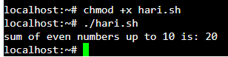

PROGRAM:

7.SWAPPING OF TWO NUMBERS

INPUT:

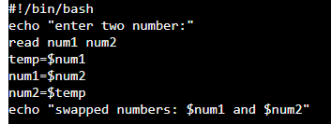

OUTPUT:



PROGRAM :

8.FINDING A NUMBER WHEATHER ARMSTRONG NUMBER OR NOT :

INPUT:

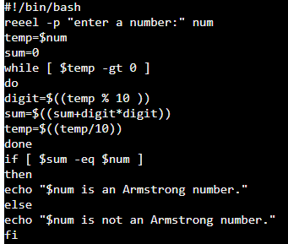

OUTPUT:

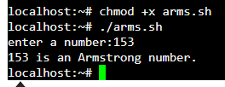

PROGRAM:

9. FINDING BIGGEST NUMBER IN AN INTEGER

INPUT: 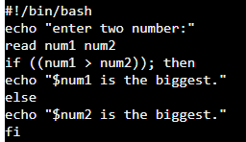

OUTPUT:



PROGRAM:

10.FINDING LARGEST INTEGER FROM GIVEN INTEGERS

INPUT:

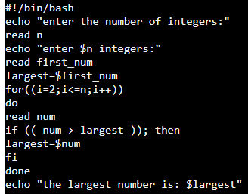

OUTPUT:

